Practice Set C: Problems 11-13

11.
(a)
dsolve('Dx = x - x^2')

ans =
1/(1+exp(-t)*C1)

syms x0; sol = dsolve('Dx = x - x^2', 'x(0) = x0')

sol =
1/(1-exp(-t)*(-1+x0)/x0)

Note that this includes the zero solution; indeed

bettersol = simplify(sol)

bettersol =
-x0/(-x0-exp(-t)+exp(-t)*x0)

subs(bettersol, x0, 0)

ans =
0

T = 0:0.1:5;

hold on
solcurves = inline(vectorize(bettersol), 't', 'x0');
for initval = 0:0.25:2.0
plot(T, solcurves(T, initval))
end
axis tight
title 'Solutions of Dx = x - x^2, with x(0) = 0, 0.25,…, 2'
xlabel 't'
ylabel 'x'
hold off

The graphical evidence suggests that: The solution that starts at zero stays there; all the others tend toward the constant solution 1.

(c)
clear all; close all; hold on
f = inline('[x(1) - x(1)^2 - 0.5*x(1)*x(2); x(2) - x(2)^2 - 0.5*x(1)*x(2)]', 't', 'x');
for a = 0:1/12:13/12
for b = 0:1/12:13/12
[t, xa] = ode45(f, [0 3], [a,b]);
plot(xa(:, 1), xa(:, 2))
echo off
end
end
axis([0 13/12 0 13/12])

(d)
The endpoints on the curves are the start points. So clearly any curve that starts out inside the first quadrant, that is one that corresponds to a situation in which both populations are present at the outset, tends toward a unique point—which from the graph appears to be about (2/3,2/3). In fact if x = y = 2/3, then the right side of both equations in (4) vanishes, so the derivatives are zero and the values of x(t) and y(t) remain constant—they don't depend on t. If only one species is present at the outset, that is you start out on one of the axes, then the solution tends toward either (1,0) or (0,1) depending whether x or y is the species present. That is precisely the behavior we saw in part (b).

(e)
close all; hold on
f = inline('[x(1) - x(1)^2 - 2*x(1)*x(2); x(2) - x(2)^2 - 2*x(1)*x(2)]', 't', 'x');
for a = 0:1/12:13/12
for b = 0:1/12:13/12
[t, xa] = ode45(f, [0 3], [a,b]);
plot(xa(:, 1), xa(:, 2))
echo off
end
end
axis([0 13/12 0 13/12])

This time most of the curves seem to be tending toward one of the points (1,0) or (0,1)—in particular, any solution curve that starts on one of the axis (corresponding to no initial poulation for the other species) does so. It seems that whichever species has a greater population at the outset will eventually take over all the population—the other will die out. But there is a delicate balance in the middle—it appears that if the two populations are about equal at the outset, then they tend to the unique population distribution at which, if you start there, nothing happens. That value looks like (1/3,1/3). In fact that is the value that renders both sides of (5) zero—analogous to the role (2/3,2/3) had in part (d).

(f)
It makes sense to refer to the model (4) as "peaceful coexistence", since whatever initial populations you have—provided both are present—you wind up with equal populations eventually. "Doomsday" is an appropriate name for model (5), since if you start out with unequal populations, then the smaller group becomes extinct. The lower coefficient 0.5 means relatively small interaction between the species, allowing for coexistence. The larger coefficient 2 means stronger inteaction and competition precluding the survival of both.

12.

Here is a SIMULINK model for redoing the Pendulum application from Chapter 9:

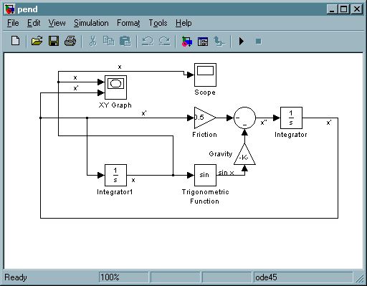

With the initial conditions x(0) = 0, $\overset{˙}{x}$(0) = 10, the XY Graph block shows the following phase portrait:

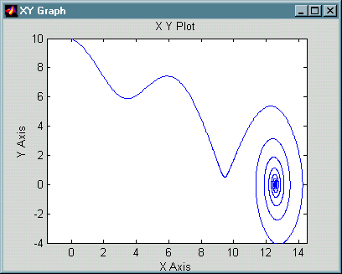

Meanwhile, the Scope block gives the following graph of x as a function of t:

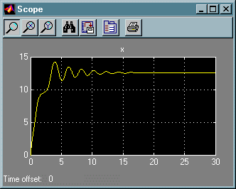

13.

Here is a SIMULINK model for studying the equation of motion of a baseball:
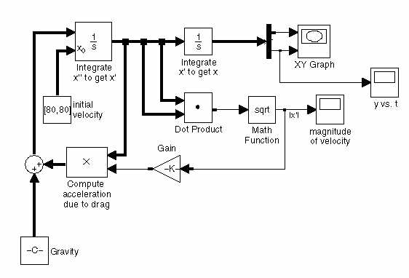
The way this works is fairly straightforward. The Integrator block in the upper left integrates the acceleration (a vector quantity) to get the velocity (also a vector – we have chosen the option, from the Format menu, of indicating vector quantities with thicker arrows). This block requires the initial value of the velocity as an initial condition; we define it in the "initial velocity" Constant block. Output from the first Integrator goes into the second Integrator, which integrates the velocity to get the position (also a vector). The initial condition for the position, [0, 4], is stored in the parameters of this second Integrator. The position vector is fed into a Demux block, which splits off the horizontal and vertical components of the position. These are fed into the XY Graph block, and also the vertical component is fed into a scope block so that we can see the height of the ball as a function of time. The hardest part is the computation of the acceleration:
$$\overset{¨}{x}=[0,−g]−c \left\|\overset{˙}{x}\right\| \overset{˙}{x} \text{.}$$
This is computed by adding the two terms on the right with the Sum block near the lower left. The value of [0, −g] is stored in the "gravity" Constant block. The second term on the right is computed in the Product block labeled "Compute acceleration due to drag," which multiplies the velocity (a vector) by −c times the speed (a scalar). We compute the speed by taking the dot product of the velocity with itself and then taking the square root; then we multiply by −c in the Gain block in the middle bottom of the model. The Scope block in the lower right plots the ball's speed as a function of time.

(a)
With c set to 0 (no air resistance) and the initial velocity set to [80, 80], the ball follows a familiar parabolic trajectory, as seen in the following picture:

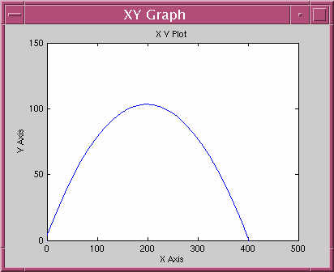

Note that the ball travels about 400 feet before hitting the ground, so the trajectory is just about what is required for a home run in most ballparks. We can read off the flight time and final speed from the other two scopes:

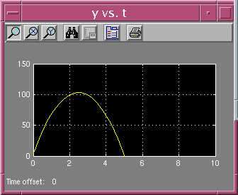

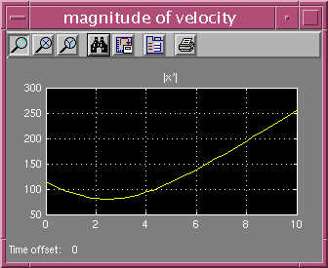

Thus the ball stays in the air about 5 seconds and is traveling about 115 ft/sec when it hits the ground.

Now lets' see what happens when we factor in air resistance, again with the initial velocity set to [80, 80]. First we take c = 0.0017. The trajectory now looks like this:

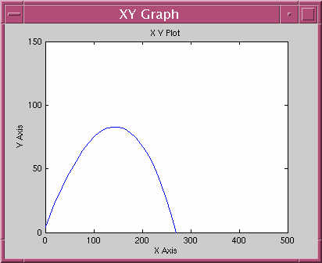

Note the enormous difference air resistance makes; the ball only travels about 270 feet. We can also investigate the flight time and speed with the other two scopes:

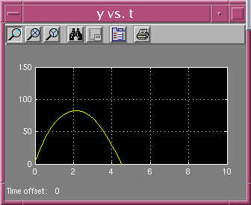

So the ball is about 80 feet high at its peak, and hits the ground in about 4½ seconds. Its final speed can be read off from the picture:

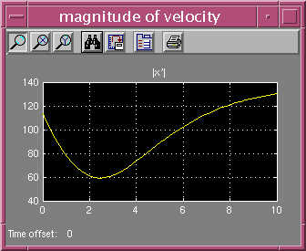

So the final speed is only about 80 ft/sec, which is much gentler on the hands of the outfielder than in the no-air-resistance case.

(b)
Let's now redo exactly the same calculation with c = 0.0014 (corresponding to playing in Denver). The ball's trajectory is now:
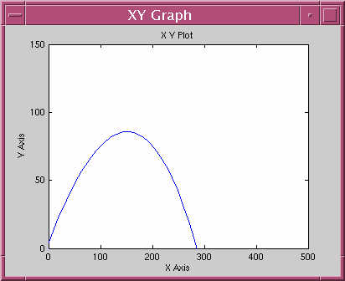

The ball goes about 285 feet, or about 15 feet further than when playing at sea level. This particular ball is probably an easy play, but with some hard-hit balls, those extra 15 feet could mean the difference between an out and a home run. If we look at the height scope for the Denver calculation, we see:

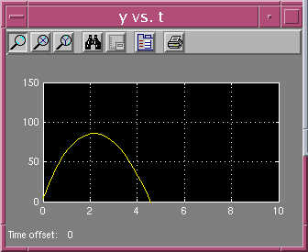

so there is a very small increase in the flight time. Similarly, if we look at the speed scope for the Denver calculation, we see:
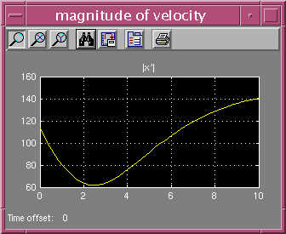

so the final speed is a bit faster, about 83 ft/sec.

(c)
One would expect that batting averages would be higher in Denver, as indeed is the case according to Major League Baseball statistics.

